Bug2Safe: Web Vulnerabilities Scanner

CREATIVE AND INNOVATIVE PROJECT (CIP) REPORT
Batch 2022 (Semester VI)

SUBMITTED BY

E.SRI THANMAI
REG.No.11239a036
P. SSSV SARVAN
REG.No.11239A065

GUIDED BY
V.BALU
ASSISTANT PROFESSOR


Department OF COMPUTER SCIENCE & ENGineering

SRI CHANDRASEKHARENDRA SARASWATHI VISWA MAHAVIDYALAYA

[APRIL/MAY-2026]
Sri Chandrasekharendra Saraswathi Viswa Mahavidyalaya
Enathur, Kanchipuram – 631 561

BONAFIDE CERTIFICATE

This is to certify that the CIP Report entitled [……BUG2SAFE……….] is the 2onafide work carried out by Mr. P. SARVAN Ms. E. SEI THANMAI Reg.No 11239A026 & 11239A065 during the academic year 2025-2026.

V.BALU DR. M .Senthil kumaran
Assistant professor Head of The Department
Department of CSE, Department of CSE,
SCSVMV. SCSVMV.

Submitted for the project work viva – voce examination held on _________________

Place : Enathur.
Date :

Examiner 1 Examiner 2

DECLARATION

It is certified that the CIP work titled _____________BUG2SAFE________________ is originally implemented by me. No ideas, processes, results or words of others have been presented as my own work. Due acknowledgement is given wherever others’ work or ideas are utilized.
- There is no fabrication of data or results which have been compiled /analyzed.
- There is no falsification by manipulating data or processes, or changing or omitting data or results.
I understand that the project is liable to be rejected at any stage (even at a later date) if it is discovered that the project has been plagiarized, or significant code has been copied. I understand that if such malpractices are found, the project will be disqualified, and the Degree awarded itself will become invalid.

E. sri thanmai
P. Sarvan

Signature of the student with date

TABLE OF CONTENTS

Chapter No: | Title | Page No.
 | ABSTRACT | I
 | LIST OF TABLES | II
 | LIST OF FIGURES | III
 | LIST OF ABBREVIATION | IV
1. | Introduction | 10
 | 1.1 Objectives | 11
 | 1.2 Scope of the project | 12
 | 1.3 Existing System | 13
 | 1.4 Drawbacks of Existing System | 14
2. | Literature Survey
 | 2.1 Literature Survey | 16
 | 2.2 Problem Statement | 18
3. | Proposed Method / Algorithm /Architecture / Process / Methodology / Project Description
 | 3.1 Proposed method | 20
 | 3.2 Algorithm | 22
 | 3.3 Architecture | 24
 | 3.4 Process | 25
 | 3.5 Modules and project Description | 26
 | 3.6 Methodology | 27
4. | Implementation Work
 | 4.1 Implementation process | 28
 | 4.2 Sample Code | 29
 | 4.3 Testing and methodologies | 32
 | 4.4 Experimental Graphs | 33
 | 4.5 Result Analysis / Result comparison | 37
5. | Conclusion
 | 5.1 conclusion | 40
 | 5.2References | 43

Abstract

Web applications have become a fundamental part of modern digital systems, supporting services such as banking, e-commerce, education, and communication. As their usage increases, security has become a major concern. Many web applications are developed without proper secure coding practices, making them vulnerable to cyber threats. Among the most critical vulnerabilities are SQL Injection and Cross Site Scripting (XSS), which are included in the OWASP Top 10 security risks. These vulnerabilities allow attackers to gain unauthorized access, manipulate data, and execute malicious scripts, leading to serious security breaches. This project presents Bug2Safe, a web-based vulnerability scanning tool designed to detect security weaknesses in web applications. The system focuses on providing a simple and user-friendly solution for identifying vulnerabilities based on OWASP Top 10 standards. Unlike complex professional tools, Bug2Safe is designed to be accessible for beginners and students, making vulnerability detection easier and more understandable. The system allows users to input a website URL and performs an automated scanning process. It follows a modular architecture, where each module is responsible for detecting specific vulnerabilities such as SQL Injection, Cross-Site Scripting (XSS), security header issues, and SSL-related problems. The detection process is based on payload injection and response analysis, where the system sends test inputs and analyzes responses to identify vulnerabilities. Additionally, the system classifies detected vulnerabilities into High, Medium, and Low risk levels, helping users understand severity and prioritize fixes effectively. The system is implemented using Flask for backend processing and HTML, CSS, and JavaScript for the frontend interface. It not only detects vulnerabilities but also enhances awareness of secure coding practices by demonstrating real-world security issues.

Keyword: Web Application Security, Vulnerability Scanner, OWASP Top 10, SQL Injection, Cross-Site Scripting (XSS), Risk Classification, Cybersecurity, Secure Coding, Flask Framework, Web Security Analysis

LIST OF FIGURES:

S.NO | FIG NO. | TITLE | PAGE NO.
1. | 3.3.1 | System Architecture of Bug2Safe | 24
2. | 4.4.1 | Time Taken for Scanning | 33
3. | 4.4.2 | Payload Effectiveness | 34
4. | 4.4.3 | Security Improvement (Before vs After Fix) | 35
5. | 4.4.4 | Detection Accuracy per Vulnerability | 36
6. | 4.5.1 | Home Page | 37
7. | 4.5.2 | Scan Page Interface | 38
8. | 4.5.3 | Vulnerability Scan Result Output | 39

LIST OF ABBREVIATION

S.No | Abbreviations | Full Form
1. | XSS | Cross-Site Scripting
2. | SQL | Structured Query Language
3. | OWASP | Open Web Application Security Project
4. | URL | Uniform Resource Locator
5. | HTTP | HyperText Transfer Protocol
6. | HTTPS | HyperText Transfer Protocol Secure
7. | SSL | Secure Sockets Layer
8. | DAST | Dynamic Application Security Testing
9. | API | Application Programming Interface
10. | UI | User Interface
11. | CSE | Computer Science and Engineering
12. | CIP | Creative and Innovative Project
13. | CSRF | Cross-Site Request Forgery
14. | CSS | Cascading Style Sheets
13. | HTML | HyperText Markup Language
16. | JS | JavaScript

Chapter 1

Introduction
Web applications have become an essential part of modern life, supporting communication, business operations, financial transactions, education, healthcare, and entertainment. With the rapid growth of internet technologies, cloud computing, and mobile accessibility, users can now access services anytime and from anywhere, increasing reliance on web-based systems. Organizations worldwide depend on these applications for critical functions such as online banking, e-commerce, data storage, and real-time communication, making them a core component of the global digital infrastructure. However, this widespread use also exposes web applications to the internet, making them prime targets for cyberattacks that can lead to financial loss, data breaches, reputational damage, and legal consequences.
• Web applications are widely used across multiple industries
• They provide real-time, anywhere access to services
• They are critical to modern digital infrastructure
One major reason for the growing number of security issues is the lack of secure coding practices during development. Developers often focus more on functionality, performance, and user experience, while security is treated as a secondary concern. This leads to applications that work efficiently but contain hidden vulnerabilities. Common issues include improper input validation, weak authentication, insecure session management, and poor error handling. Among these, SQL Injection and Cross-Site Scripting (XSS) are especially dangerous, allowing attackers to manipulate databases or inject malicious scripts into web pages. These vulnerabilities are consistently listed in the OWASP Top 10, highlighting their significance in web security.
• Security is often overlooked during development
• Common flaws include weak validation and authentication
• SQL Injection and XSS are major and widely exploited threats
To identify and address such risks, organizations use vulnerability scanning tools that automatically detect security weaknesses by simulating real-world attack scenarios. While these tools are effective, they are often complex, resource-intensive, and designed for experienced cybersecurity professionals. This makes them difficult for beginners, students, and small-scale developers to use. Additionally, many tools generate highly technical reports that are hard to understand, making it challenging for users to interpret vulnerabilities and apply fixes. As a result, there is a strong need for a simpler, more accessible solution that combines detection with clear explanation and learning support.
• Tools simulate attacks to detect vulnerabilities
• Many tools are complex and not beginner-friendly
• Reports are difficult to interpret for non-experts
The Bug2Safe project is developed to address these challenges by providing a simple, efficient, and educational web-based vulnerability scanner. It detects common issues such as SQL Injection, XSS, security header misconfigurations, and SSL-related problems using automated techniques. The system follows a modular architecture for scalability and allows users to scan a target URL easily while receiving real-time feedback and clear, severity-based reports. Unlike traditional tools, Bug2Safe focuses on usability and understanding, helping users not only identify vulnerabilities but also learn how to prevent them. This makes it both a practical security tool and an educational platform that promotes secure coding practices and improves overall web application security awareness.
• Detects common vulnerabilities using automated scanning
• Provides real-time feedback with simple reports
• Promotes secure coding and acts as a learning tool
1.1 OBJECTIVES
The primary objective of the Bug2Safe project is to develop a web-based vulnerability scanner that can efficiently detect and classify security flaws in web applications based on the OWASP Top 10 standards. The system aims to provide an automated solution that simplifies the process of vulnerability assessment, enabling users to identify potential risks without requiring extensive expertise in cybersecurity. By focusing on commonly exploited vulnerabilities such as SQL Injection and Cross-Site Scripting, the project ensures that the most critical threats are effectively addressed. Another important objective of the project is to design a user-friendly interface that allows easy interaction with the system. The application includes a login mechanism to ensure controlled access and provides a simple input field for entering target URLs. The results of the scanning process are presented in a structured format, with vulnerabilities categorized into High, Medium, and Low risk levels. This classification helps users prioritize their mitigation efforts and enhances their understanding of the severity of each issue. The project also aims to implement a modular architecture that supports scalability and future enhancements. Each vulnerability detection mechanism is designed as a separate module, allowing additional features to be integrated without affecting the overall system functionality. This modular approach ensures flexibility and maintainability, making the system adaptable to evolving security requirements and emerging threats in web applications. Finally, the Bug2Safe project seeks to promote awareness about web security and encourage the adoption of secure coding practices. By providing a practical tool for vulnerability detection, the system serves as an educational resource for students and developers. It highlights the importance of proactive security measures and demonstrates how automated tools can be used to identify and mitigate risks effectively, thereby contributing to the development of more secure web applications. • Develop a web-based vulnerability scanning tool
• Detect SQL Injection and XSS vulnerabilities
• Analyze security headers and SSL issues
• Classify vulnerabilities based on severity

1.2 SCOPE OF THE PROJECT
The scope of the Bug2Safe project encompasses the complete design, development, and implementation of a web-based vulnerability scanning system that is capable of analyzing web applications for common security weaknesses in an automated and user-friendly manner. The project is primarily focused on addressing the challenges associated with web application security by providing a simplified yet effective solution that can be used by students, beginner developers, and small-scale organizations. Within its defined scope, the system allows users to input a target website URL and perform vulnerability scans that simulate real-world attack scenarios, enabling the detection of critical issues such as SQL Injection and Cross-Site Scripting (XSS). These vulnerabilities are chosen due to their high prevalence and significant impact on web application security, making them essential areas of focus for any security assessment tool. In addition to these core vulnerabilities, the system also evaluates security headers and SSL configurations, ensuring that the application adheres to best practices for secure communication and data protection. The project is designed to be lightweight and easily deployable, eliminating the need for complex installation procedures or extensive configuration, which are often associated with professional security tools. This makes Bug2Safe highly accessible and suitable for educational purposes, where ease of use and clarity of results are of utmost importance. However, it is important to note that the scope of the project is intentionally limited to basic vulnerability detection and does not include advanced penetration testing features such as deep network analysis, exploitation frameworks, or automated attack chaining. The primary goal is to provide a foundational understanding of web application security rather than replacing enterprise-level security solutions. By focusing on simplicity, usability, and educational value, the project ensures that users can effectively learn about security concepts while also gaining practical experience in identifying and analyzing vulnerabilities. The modular architecture of the system also allows for future enhancements, enabling additional features and vulnerability checks to be integrated as the project evolves.
• Provides a web-based vulnerability scanner that detects common issues like SQL Injection, XSS, and checks security headers and SSL configurations.
• Focuses on simplicity, accessibility, and educational use, with limited scope

1.3 EXISTING SYSTEM
The existing systems for web vulnerability detection are predominantly composed of advanced security tools and frameworks that are widely used in the cybersecurity industry for identifying and mitigating security risks. These tools include both commercial and open-source solutions, such as automated vulnerability scanners, penetration testing frameworks, and security auditing platforms, which are designed to perform comprehensive assessments of web applications. They utilize a combination of techniques such as static analysis, dynamic analysis, and interactive testing to detect vulnerabilities across different layers of the application. While these tools are highly effective and capable of identifying a wide range of security issues, they are often complex in nature and require a significant level of expertise to operate effectively. Users are expected to have a strong understanding of web technologies, networking protocols, and security principles in order to configure the tools, execute scans, and interpret the results accurately. Another notable characteristic of existing systems is their emphasis on detailed reporting and extensive feature sets, which, while beneficial for professional use, can be overwhelming for beginners. The reports generated by these tools typically contain large amounts of technical data, including logs, payload details, and response patterns, which may be difficult for inexperienced users to understand. Additionally, many commercial tools come with high licensing costs, making them inaccessible to students and small-scale developers who may not have the resources to invest in such solutions. Even open-source tools, despite being freely available, often require complex setup processes, including dependency management, environment configuration, and integration with other systems, which can be time-consuming and challenging for users with limited technical knowledge. Furthermore, most existing systems focus primarily on vulnerability detection and do not provide sufficient educational insights into the causes and prevention of security issues, leaving users with limited understanding of how to improve their applications. • Existing tools are highly advanced and feature-rich, using techniques like static and dynamic analysis for comprehensive vulnerability detection.
• They are often complex, expensive, and require expert knowledge, making them difficult for beginners and students to use effectively.

1.4 DRAWBACKS OF EXISTING SYSTEM
Despite their effectiveness in identifying vulnerabilities, existing web vulnerability scanning systems suffer from several significant drawbacks that limit their usability, particularly for beginners and educational purposes. One of the most prominent issues is the complexity associated with these tools, as they are often designed with professional cybersecurity experts in mind. This results in steep learning curves, where users must invest considerable time and effort to understand the functionalities, configurations, and outputs of the tools. For students and novice developers, this complexity can be discouraging and may hinder their ability to learn and apply security concepts effectively. Additionally, the reliance on command-line interfaces and advanced configurations in many tools further increases the difficulty level, making them less accessible to users who prefer simple and intuitive graphical interfaces. Another major drawback is the cost factor associated with many commercial vulnerability scanning tools, which can be prohibitively expensive for individuals and educational institutions. This limits access to high-quality security tools and creates a barrier for learning and experimentation. Furthermore, the reports generated by these tools are often highly technical and lack clear explanations, making it difficult for users to understand the nature of vulnerabilities and the steps required to fix them. This lack of clarity reduces the educational value of these tools and prevents users from gaining a deeper understanding of web security. In addition, existing systems often focus solely on detection and do not emphasize preventive measures or secure coding practices, leaving developers without guidance on how to avoid similar vulnerabilities in the future. These limitations highlight the need for a simplified, cost-effective, and educational vulnerability scanning solution that can bridge the gap between detection and learning, which is precisely what the Bug2Safe project aims to achieve.
• Tools are complex and difficult to learn, with technical reports and command line usage that are not beginner-friendly.
• High cost and lack of clear explanations or educational guidance limit accessibility and understanding of security concepts.

Chapter 2

Literature Survey

2.1 Literature
Deep learning has witnessed rapid advancements over the past decade, driven by the development of powerful architectures such as Generative Adversarial Networks (GANs) and transformer-based models. These technologies have significantly enhanced the realism of synthetic media, particularly deepfakes, making them increasingly difficult to distinguish from authentic content. As a result, deepfake detection has emerged as a critical research domain within digital forensics, cybersecurity, and multimedia authentication. This section reviews major research contributions in the field, focusing on spatial analysis, multimodal learning, temporal modeling, frequency-based detection, and explainable artificial intelligence techniques.
Initial research efforts in deepfake detection primarily focused on identifying visual artifacts using Convolutional Neural Networks (CNNs). Kumar et al. [1] proposed a CNN-based framework integrated with attention mechanisms to capture subtle inconsistencies in facial regions such as eyes, lips, and skin textures. Their work demonstrated that attention layers improve the model’s ability to focus on manipulated regions. Similarly, Li et al. [2] introduced a method to detect face warping artifacts caused by deepfake generation processes, highlighting that geometric distortions and resolution inconsistencies serve as reliable indicators of manipulated media.
As deepfake generation techniques became more sophisticated, relying solely on visual features proved insufficient. This led to the development of multimodal detection approaches that combine multiple sources of information. Nguyen et al. [3] proposed an audio-visual fusion model that integrates facial expressions and speech characteristics, significantly improving detection accuracy compared to unimodal systems. Wang et al. [5] further enhanced multimodal detection by incorporating attention-based feature fusion mechanisms, enabling the model to dynamically prioritize relevant features across modalities. Verma and Sharma [12] conducted a comprehensive survey on multimodal fusion techniques, emphasizing their effectiveness in handling complex and high-quality deepfake content.
In addition to visual manipulation, advancements in synthetic speech generation have increased the prevalence of audio deepfakes. Chandrasekaran and Rao [6] developed a spectrogram-based CNN model that analyzes frequency-domain features of audio signals. Their study demonstrated that Mel-spectrogram representations effectively capture subtle anomalies in synthetic speech, making them highly suitable for audio deepfake detection.
Temporal analysis has also become a crucial component in detecting deepfake videos, as many manipulations introduce inconsistencies across consecutive frames. Zhao et al. [7] proposed a temporal inconsistency learning framework that identifies irregular motion patterns and frame-level discrepancies. Kim et al. [9] introduced a hybrid CNN-LSTM architecture that captures both spatial and temporal features, significantly improving detection performance in video datasets. Chen et al. [17] extended this work by integrating spatio-temporal feature learning into a unified framework, resulting in improved robustness against advanced deepfake techniques.
More recently, transformer-based architectures have gained attention due to their ability to model long-range dependencies and global contextual information. Almutairi et al. [13] proposed a hybrid CNN–Vision Transformer model that combines local feature extraction with global attention mechanisms, outperforming traditional CNN-based approaches. Wang et al. [20] further advanced this concept by introducing multimodal transformer-based models, enabling effective cross-modal feature learning and improving detection accuracy in complex scenarios.
Frequency-domain analysis has emerged as another promising direction in deepfake detection. Kaur and Singh [8] demonstrated that GAN-generated images exhibit distinct frequency artifacts that are not easily visible in the spatial domain. By analyzing these artifacts, their model achieved high classification accuracy. Sharma et al. [16] further improved detection performance by combining spatial and frequency-domain features, highlighting the complementary nature of these approaches.
Explainability has become an essential requirement in deepfake detection systems, particularly for forensic and legal applications. Shah et al. [10] utilized Grad-CAM techniques to visualize the regions influencing model predictions, providing insights into the decision-making process. Similarly, Rao et al. [19] employed saliency maps to enhance transparency and interpretability, ensuring that detection systems are trustworthy and reliable.
A significant challenge in deepfake detection is the ability to generalize across different datasets and manipulation techniques. Zhang et al. [11] addressed this issue using transfer learning strategies, improving cross-dataset performance and robustness. Agarwal and Farid [4] highlighted the broader implications of deepfakes, emphasizing the need for reliable detection systems to combat misinformation and protect individuals from malicious attacks.
Recent research has also focused on developing lightweight and real-time detection systems to enable practical deployment. Reddy et al. [14] proposed a real-time detection framework using lightweight neural networks, achieving a balance between accuracy and computational efficiency. Iyer and Krishnan [18] demonstrated that EfficientNet-based architectures can be effectively deployed on edge devices with reduced resource consumption. Furthermore, Gupta and Mehta [15] emphasized the importance of multimodal deep learning frameworks, showing that integrating audio and visual features leads to improved detection performance.
In summary, the literature highlights significant progress in deepfake detection through the use of advanced deep learning techniques, multimodal fusion, and explainable AI. However, challenges such as generalization, computational complexity, and real-time deployment remain open research problems. These limitations indicate the need for robust, scalable, and interpretable detection systems capable of handling evolving deepfake technologies.

2.2 Problem Statement
The rapid growth of web applications has introduced significant security challenges, as many applications are developed without adequate consideration for security practices. Developers often focus on delivering functionality and meeting deadlines, resulting in applications that contain vulnerabilities which can be easily exploited by attackers. This issue is further compounded by the increasing complexity of modern web applications, which involve multiple layers of technologies, frameworks, and third-party integrations. As a result, identifying and addressing security vulnerabilities has become a critical yet challenging task. Traditional methods of vulnerability detection, such as manual code reviews and penetration testing, require significant expertise, time, and resources, making them impractical for small-scale developers and students. While automated vulnerability scanning tools are available, they are often complex, expensive, and difficult to use, creating a barrier for individuals who wish to learn about web security or perform basic security assessments.
- Security is often overlooked due to focus on deadlines and functionality
- Modern applications are complex with multiple integrations
- Existing tools are costly and difficult for beginners
Another major problem is the lack of awareness and understanding of secure coding practices among developers, particularly those who are new to the field. Many developers are not familiar with common vulnerabilities such as SQL Injection and Cross-Site Scripting (XSS), and even when they are aware of these issues, they may not fully understand how to prevent them. Existing tools often provide detailed technical reports without sufficient explanation, making it difficult for users to interpret the results and take corrective actions. The Bug2Safe project addresses these challenges by providing a simplified and accessible web-based vulnerability scanning tool that automates the detection of common security flaws while also emphasizing educational value. The system is designed to be easy to use, allowing users to perform scans by simply entering a website URL, without requiring complex configurations or technical expertise. By focusing on critical vulnerabilities such as SQL Injection and XSS, and providing clear explanations and risk classifications, the tool helps users understand the nature and impact of security issues. Additionally, the project aims to promote awareness of secure coding practices by demonstrating real-world vulnerabilities and encouraging developers to adopt preventive measures during the development process. Through its user-friendly design and educational approach, Bug2Safe seeks to bridge the gap between complex security tools and beginner-level understanding, providing an effective solution for improving web application security awareness and implementation.
- Developers lack awareness of secure coding practices
- Reports from tools are difficult to understand
- Bug2Safe provides a simple, educational, and user-friendly solution
Chapter 3

Proposed Method / Algorithm / Architecture / Process / Methodology / Project Description

3.1 PROPOSED METHOD
The proposed system, Bug2Safe, is designed as a comprehensive, modular, and web-based vulnerability scanning platform that focuses on detecting common security flaws in web applications while maintaining simplicity, efficiency, and accessibility. The core idea behind the proposed method is to simulate real-world attack scenarios in a controlled and automated manner, enabling the system to identify vulnerabilities such as SQL Injection, Cross-Site Scripting (XSS), insecure HTTP headers, and SSL-related issues. Unlike traditional vulnerability scanners that require extensive configuration and technical expertise, Bug2Safe adopts a streamlined approach where users only need to provide a target URL, and the system handles the entire scanning process internally. This approach not only simplifies usability but also ensures that the tool can be effectively used by beginners and students who are still learning about web security concepts.
- Simulates real-world attack scenarios in a controlled environment
- Focuses on common vulnerabilities like SQL Injection and XSS
- Requires only a target URL for scanning
The methodology follows a structured pipeline that begins with user input, where the target web application URL is provided through a frontend interface developed using HTML, CSS, and JavaScript. Once the URL is submitted, the backend system, implemented using the Flask framework, initiates the scanning process by sending HTTP requests to the target application. These requests are embedded with specially crafted payloads designed to test for specific vulnerabilities. For instance, SQL Injection detection involves injecting malicious SQL queries into input fields and analyzing the server’s response for abnormal behavior, such as database errors or unauthorized data retrieval. Similarly, Cross-Site Scripting detection involves injecting script-based payloads into the application and observing whether they are executed in the browser, indicating a lack of proper input sanitization. This payload-based testing mechanism forms the foundation of the proposed method, as it closely replicates the techniques used by real attackers.
- Frontend built using HTML, CSS, and JavaScript
- Backend implemented using Flask framework
- Uses payload-based testing similar to real attacker techniques
Another critical aspect of the proposed method is response analysis, which involves examining the server’s output to determine whether a vulnerability exists. The system uses pattern matching and heuristic techniques to identify anomalies in responses, such as error messages, unexpected redirects, or script execution. This analysis is performed dynamically, allowing the system to adapt to different types of web applications and detect vulnerabilities in real time. This design ensures that the system is scalable and can be easily extended to include additional vulnerability checks in the future. For example, new modules can be added to detect authentication flaws, file inclusion vulnerabilities, or API security issues without affecting the existing functionality.
- Uses pattern matching and heuristic-based response analysis
- Detects anomalies like errors and unexpected redirects
- Modular design allows easy future expansion
Furthermore, the proposed method includes a risk classification mechanism that categorizes detected vulnerabilities into High, Medium, and Low severity levels based on their potential impact and exploitability. This classification helps users prioritize remediation efforts and focus on critical issues first. The results are presented through an interactive frontend interface, where users can view detailed reports, including the type of vulnerability, affected parameters, and recommended mitigation strategies. By combining automated scanning, modular design, and user-friendly reporting, the proposed method provides a balanced approach that addresses both functional and educational aspects of web application security. Overall, Bug2Safe represents a practical and efficient solution for vulnerability detection, bridging the gap between complex professional tools and beginner-level understanding.
- Classifies vulnerabilities into severity levels
- Provides detailed and user-friendly reports
- Helps users prioritize security fixes effectively
3.2 ALGORITHM
The Bug2Safe vulnerability scanning algorithm is designed to provide a structured and automated approach for detecting security flaws in web applications. It systematically evaluates a target URL by injecting controlled payloads, analyzing server responses, and identifying potential vulnerabilities such as SQL Injection, Cross-Site Scripting (XSS), and missing security headers. The algorithm ensures proper validation, scanning, classification, and reporting, making the process efficient, reliable, and suitable for both learning and practical security assessment.

Algorithm Bug2Safe_Vulnerability_Scanner
Input: Target_URL
Output: Vulnerability_Report
BEGIN
- // Phase 1: Initialization
Load HTTP_Request_Module
Load Payload_Library (SQLi, XSS, Headers)
Initialize Response_Analyzer
Initialize Result_Storage
- // Phase 2: Input Validation
IF Target_URL is NULL OR Invalid_Format THEN
Display "Invalid URL"
TERMINATE
END IF
Send Test_Request to Target_URL
IF Response_Status != 200 THEN
Display "Target Not Reachable"
TERMINATE
END IF
- // Phase 3: Scanning Preparation
Extract Input_Parameters from Target_URL
Identify Attack_Surface (Forms, Query Params, Headers)
- // Phase 4: Vulnerability Scanning Loop
FOR each Vulnerability_Type in [SQL_Injection, XSS, Security_Headers] DO
FOR each Input_Point in Attack_Surface DO
FOR each Payload in Payload_Library[Vulnerability_Type] DO
Inject Payload into Input_Point
Send HTTP_Request to Server
Capture Server_Response
// Phase 5: Response Analysis
IF Analyze_Response(Server_Response, Vulnerability_Type) == TRUE THEN
Record Vulnerability:
- Type
- Payload Used
- Affected Parameter
- Response Evidence
END IF
END FOR
END FOR
- // Phase 6: Security Header Analysis
Send HTTP_Request(Target_URL)
Extract Response_Headers
FOR each Required_Header in [CSP, X-Frame-Options, HSTS] DO
IF Header NOT Present THEN
Record Missing_Header_Vulnerability
END IF
END FOR
- // Phase 7: Vulnerability Classification
FOR each Detected_Vulnerability DO
IF Critical Impact THEN
Assign Severity = HIGH
ELSE IF Moderate Impact THEN
Assign Severity = MEDIUM
ELSE
Assign Severity = LOW
END IF
END FOR
- // Phase 8: Report Generation
Compile Vulnerability_Report including:
- Vulnerability Type
- Affected Location
- Severity Level
- Description
- Recommended Fix
- // Phase 9: Output
Display Vulnerability_Report to User
END

The above algorithm represents a complete end-to-end workflow of the Bug2Safe system, covering initialization, input validation, payload-based scanning, response analysis, security header verification, vulnerability classification, and final report generation. It ensures systematic detection of security issues while maintaining accuracy and modularity in execution.
3.3 SYSTEM ARCHITECTURE
The architecture of Bug2Safe is designed using a well-structured layered approach to ensure smooth communication between all system components. It separates the system into distinct layers such as the frontend, backend, and scanning engine to improve modularity and maintainability. Each layer performs a specific role and interacts with others through defined communication protocols. This separation helps in reducing system complexity and allows independent development and updates of each module. The following diagram represents the overall system architecture of Bug2Safe and how all components are interconnected.
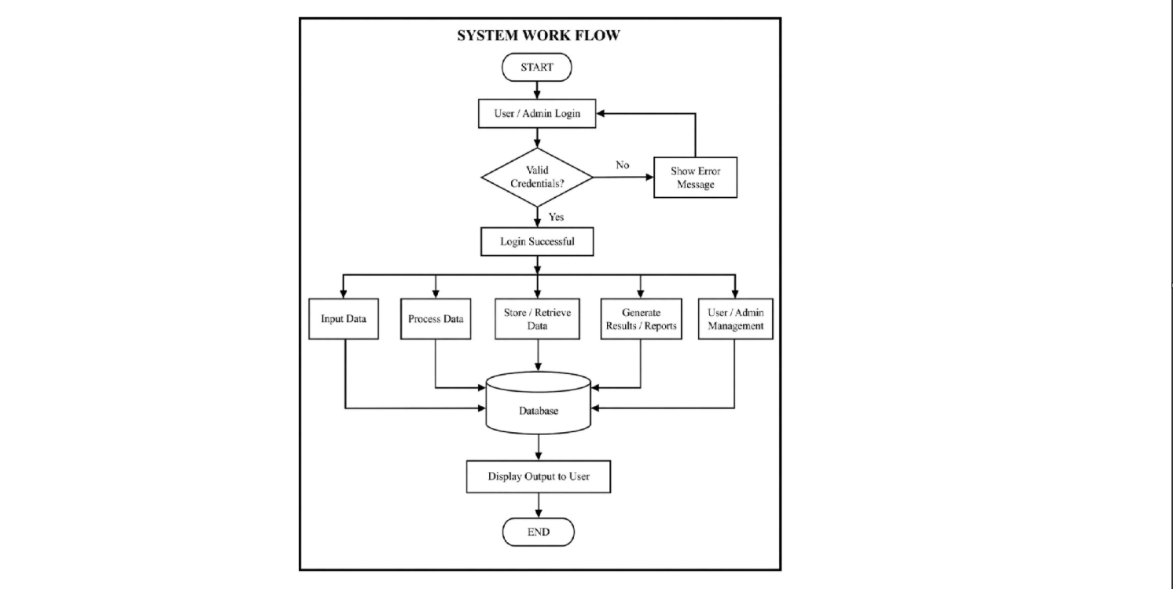

The above architecture clearly illustrates how data flows through different layers of the Bug2Safe system during vulnerability scanning. The frontend layer is responsible for collecting user input and displaying scan results in a structured and user-friendly manner. The backend layer processes the input, manages requests, and coordinates with the scanning engine for execution. The scanning engine performs the core vulnerability detection by interacting with the target application and analyzing responses. Overall, this layered design ensures high efficiency, scalability, and maintainability of the Bug2Safe system while supporting secure and organized scanning operations.
3.4 PROCESS DESCRIPTION
3.4 PROCESS DESCRIPTION
- The Bug2Safe system follows a structured and automated workflow for detecting vulnerabilities in web applications.

- The process begins when the user accesses the web-based interface of the system.

- The user provides the target URL of the web application to be analyzed.

- The frontend interface sends the input to the backend for processing.

- The backend server validates the URL format and checks its accessibility.

- If the URL is invalid or unreachable, the system stops execution and requests valid input.

- Once validated, the system initializes the scanning environment.

- All required scanning modules and libraries are loaded into the system memory.

- The payload database containing SQL Injection, XSS, and other attack vectors is activated.

- The system identifies potential input points in the target application such as forms and parameters.

- The scanning engine begins sending HTTP requests to the target application.

- Each request is embedded with specific payloads designed to test vulnerabilities.

- The system simulates real-world attack behavior in a controlled environment.

- Responses from the target application are captured in real time.

- The response data is analyzed to detect anomalies, errors, or malicious execution.

- Any detected vulnerabilities are recorded along with relevant evidence and parameters.

- The system classifies vulnerabilities based on severity levels such as High, Medium, and Low.

- After completing the scan, a detailed report is generated and displayed to the user through the interface.

3.5 MODULES AND DESCRIPTION

Project Modules
- user Interface Module
  - Provides an interactive platform for users to enter the target website URL.
  - Displays scan results in a clear and structured format.
- URL Processing Module
  - Validates the input URL for correctness and accessibility.
  - Extracts parameters and prepares the URL for scanning.
- Scanning Module
  - Performs automated vulnerability detection using payload injection.
  - Sends HTTP requests to simulate attacks like SQL Injection and XSS.
- Response Analysis Module
  - Analyzes server responses for errors and abnormal patterns.
  - Identifies vulnerabilities based on predefined rules.
- Security Evaluation Module
  - Checks HTTP security headers and SSL configurations.
  - Ensures adherence to secure communication practices.
- Vulnerability Classification Module
  - Categorizes vulnerabilities into High, Medium, and Low risk levels.
  - Helps in prioritizing issues based on severity.
- Reporting Module
  - Generates detailed reports with vulnerability information.
  - Provides mitigation suggestions and security recommendations.

Project Description
- System Initialization
  - Prepares all modules and loads required configurations.
  - Ensures the system is ready for scanning operations.
- User Input Handling
  - Accepts the target URL from the user interface.
  - Passes the input to the processing module.
- Input Validation and Preparation
  - Validates the URL format and checks accessibility.
  - Extracts necessary parameters for scanning.
- Vulnerability Scanning Process
  - Executes payload-based testing on identified input points.
  - Simulates real-world attack scenarios.
- Response Analysis and Detection
  - Evaluates server responses to identify vulnerabilities.
  - Detects issues like SQL Injection and XSS.
- Security Evaluation
  - Verifies presence of essential security headers.
  - Checks SSL configuration for secure communication.
- Risk Classification
  - Assigns severity levels based on impact and exploitability.
  - Organizes vulnerabilities for better understanding.
- Report Generation and Output
  - Compiles all findings into a structured report.
  - Displays results to the user in a readable format.

3.6 METHODOLOGY
- Requirement Analysis:
  - Identify web security challenges and system requirements.
  - Define objectives of the system.
  - Determine key vulnerabilities to be detected such as SQL Injection and XSS.
- Input Processing:
  - Validate the format of the target URL.
  - Ensure the target website is accessible before scanning begins.
- Payload Preparation:
  - Prepare predefined attack payloads for different vulnerability types.
  - Organize payloads for systematic and structured testing.
- Scanning Execution:
  - Perform automated vulnerability scanning on the target application.
  - Inject payloads into input fields and send HTTP requests.
- Response Analysis:
  - Analyze server responses for abnormal behavior.
  - Detect errors, unexpected outputs, and script execution.
- Security Evaluation:
  - Inspect HTTP headers for security compliance.
  - Check SSL/TLS configurations for secure communication.
- Vulnerability Detection & Classification:
  - Identify security vulnerabilities from analyzed responses.
  - Classify vulnerabilities into High, Medium, and Low severity levels based on impact.
- System Integration:
  - Integrate all modules such as UI, scanning engine, analysis module, and reporting system.
  - Ensure smooth workflow between components.
- Report Generation:
  - Generate structured vulnerability reports.
  - Include vulnerability details, severity levels, and mitigation recommendations.
- Ethical Validation:
- Ensure the system is used only for authorized and educational security testing.
- Follow ethical guidelines during all scanning operations.

Chapter 4

Implementation / Code / Testing methodologies/ Experimental graphs/ Results and Description of Results

4.1 IMPLEMENTATION PROCESS
The implementation of the Bug2Safe system represents the transformation of theoretical concepts and proposed methodologies into a fully functional web-based vulnerability scanning application. This phase involves the integration of multiple technologies, frameworks, and programming techniques to create a system that is not only capable of detecting vulnerabilities but also efficient, scalable, and user-friendly. The implementation process begins with the selection of appropriate technologies that align with the objectives of the project. The backend of the system is developed using the Flask framework, a lightweight and flexible web framework in Python that enables rapid development and easy integration of various modules. Flask is chosen due to its simplicity, minimal configuration requirements, and ability to handle HTTP requests efficiently. On the frontend, technologies such as HTML, CSS, and JavaScript are used to design an interactive user interface that allows users to input URLs, initiate scans, and view results in a structured format. The development process follows a modular approach, where each functionality is implemented as a separate component, ensuring better organization and maintainability. Initially, the basic structure of the application is created, including routing mechanisms, request handling, and response generation. The main Flask application acts as the central controller, receiving user input and coordinating the scanning process. Once the core framework is established, individual scanning modules are developed for detecting specific vulnerabilities such as SQL Injection, Cross-Site Scripting (XSS), security header issues, and SSL-related problems. Each module is designed to operate independently, allowing for easier testing and debugging. During the implementation phase, special attention is given to the design of payloads and detection logic. Payloads are carefully crafted to simulate real-world attack scenarios, ensuring that the system can effectively identify vulnerabilities. For example, SQL Injection payloads include common patterns such as logical bypass queries and union-based injections, while XSS payloads include script tags and event handlers designed to trigger execution in the browser. The system sends these payloads to the target application and analyzes the responses to detect anomalies. This requires the implementation of response parsing techniques, where the system examines the content, structure, and behavior of responses to identify signs of vulnerabilities. Another important aspect of the implementation process is error handling and validation. The system is designed to handle various edge cases, such as invalid URLs, unreachable servers, and unexpected responses, ensuring that the application remains stable and reliable under different conditions. Additionally, the system incorporates logging mechanisms that record all scanning activities, providing valuable insights for debugging and performance optimization. The implementation also includes security considerations, ensuring that the tool itself does not introduce vulnerabilities or violate ethical guidelines. Finally, the integration of frontend and backend components is carried out to create a seamless user experience. The frontend communicates with the backend through HTTP requests, sending user inputs and receiving scan results in real time. The results are then displayed in a structured and visually appealing format, allowing users to easily understand the security status of their application. The entire implementation process is iterative, involving continuous testing, debugging, and refinement to ensure that the system meets the desired performance and functionality standards.

4.2 SAMPLE CODE
1. Error Handling Scanner Module (example scanner)

import requests

def scan(url):
# Try to trigger an error
test_url = url + "/nonexistent"

try:
res = requests.get(test_url, timeout=5)

# Check for 404 response with verbose error leakage
if res.status_code == 404:
if "stack trace" in res.text.lower() or "error" in res.text.lower():
return {
"status": "Verbose Errors",
"risk": "Medium"
}

return {
"status": "Proper Error Handling",
"risk": "Low"
}

except:
return {
"status": "Error",
"risk": "Unknown"
}

2. Main Flask Application (app.py)
from flask import Flask, request, jsonify, render_template

# Import all scanner modules
from scanners import (
sqli,
xss,
headers,
ssl,
command_injection,
broken_auth,
xxe,
access_control,
deserialization,
components,
logging
)

app = Flask(__name__)

# Home Page Route
@app.route('/')
def index():
return render_template('index.html')

# Scan API Route
@app.route('/scan', methods=['POST'])
def scan():
data = request.json
url = data.get("url")

results = {
"SQL Injection": sqli.scan(url),
"Command Injection": command_injection.scan(url),
"Broken Authentication": broken_auth.scan(url),
"Sensitive Data Exposure": ssl.scan(url),
"XXE": xxe.scan(url),
"Broken Access Control": access_control.scan(url),
"Security Misconfiguration": headers.scan(url),
"XSS": xss.scan(url),
"Insecure Deserialization": deserialization.scan(url),
"Using Components with Known Vulnerabilities": components.scan(url),
"Insufficient Logging & Monitoring": logging.scan(url)
}

return jsonify(results)

# Run Flask App
if __name__ == "__main__":
app.run(debug=True)

The implementation includes a vulnerability scanning function that checks how a web application handles invalid requests and error responses. It sends a request to a non-existent endpoint and analyzes the server’s response for signs of information leakage. If the response contains sensitive details such as stack traces or generic error messages, it indicates poor error handling and is classified as a medium-risk vulnerability. If no such information is exposed, the system concludes that proper error handling is in place. This helps in identifying weaknesses where attackers could gain internal system details through error messages.
The main application is developed using the Flask framework and serves as the central component of the Bug2Safe system. It provides routes for the user interface and for handling scan requests. When a user submits a target URL, the backend forwards it to multiple vulnerability detection modules that test for issues such as SQL Injection, XSS, Command Injection, Broken Authentication, and other security flaws. Each module returns its result independently, and all outputs are combined into a single structured response. The final results are sent back in JSON format and displayed on the frontend, providing a clear and organized vulnerability report.

4.3 TESTING AND METHODOLOGIES
Testing is an essential phase in the implementation of the Bug2Safe system to ensure accuracy, reliability, and proper functionality of all components. A combination of static validation, unit testing, integration testing, API testing, and functional scenario testing is used to evaluate the system.

• Static Validation Checks
Static testing is performed before execution to identify code-level issues.
- Python compilation check using python -m compileall backend
- Frontend linting for error detection and code quality improvement
- Early identification of syntax and structural issues

• Unit Testing
Each module is tested independently to ensure correct functionality.
- Testing of vulnerability detection modules (SQLi, XSS, etc.)
- Validation of input processing and scanning functions
- Ensures each component works as expected in isolation

• Integration Testing
This ensures smooth interaction between system components.
- Verification of data flow between frontend and backend
- Testing communication between scanning engine and result modules
- Ensures consistent system behavior across modules

• API Testing
API endpoints are tested for correctness and reliability.
- URL submission and scan request validation
- Result generation and retrieval checks
- Error handling for invalid inputs

• Functional Scenario Testing
Real-world scenarios are used to test system effectiveness.
- SQL Injection and XSS test cases
- Invalid URL and edge-case handling
- Multi-page scanning workflow validation
- End-to-end testing from input to output display

• Real-World Evaluation
The system is tested using sample vulnerable websites.
- Comparison of detected vulnerabilities with expected results
- Measurement of accuracy and scanning performance
- Assessment of false positives and reliability

• Edge Case Testing
Ensures system stability under abnormal conditions.
- Empty or invalid input handling
- Unreachable or slow websites
- Prevention of system crashes under unexpected inputs
4.4 EXPERIMENTAL GRAPHS
The performance of the Bug2Safe system is evaluated using experimental graphs that illustrate key aspects such as scanning time, payload effectiveness, security improvement, and detection accuracy. These graphical representations provide a clear understanding of how efficiently the system detects and mitigates vulnerabilities like SQL Injection, XSS, and CSRF. By visualizing the results, it becomes easier to analyze system behavior, compare different parameters, and identify areas for improvement, thereby demonstrating the overall effectiveness and reliability of the proposed system.

Figure 4.4.1: Time Taken for Scanning
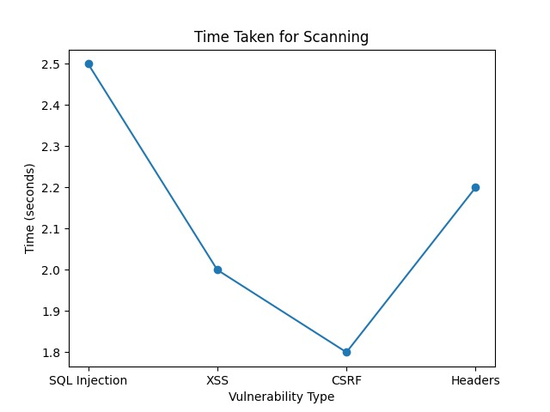
Figure 4.4.1: Time Taken for Scanning
This graph represents the performance analysis of the Bug2Safe system by showing the time required to scan different types of vulnerabilities. The X-axis shows vulnerability types such as SQL Injection, XSS, CSRF, and Headers, while the Y-axis represents the time in seconds.
From the graph, SQL Injection takes the highest time (~2.5 seconds), whereas CSRF takes the least (~1.8 seconds). This indicates that some vulnerabilities require more complex analysis and processing time. The graph helps evaluate the efficiency of the scanning process and highlights areas where optimization can reduce scanning time.

Figure 4.4.2: Payload Effectiveness

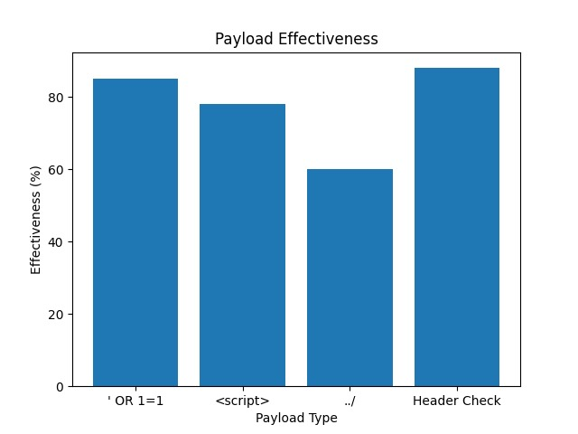

Figure 4.4.2: Payload Effectiveness
This graph shows the effectiveness of different payloads used to detect vulnerabilities. The X-axis represents payload types (e.g., ' OR 1=1, <script>, ../, Header Check), and the Y-axis shows effectiveness in percentage.
The Header Check payload shows the highest effectiveness (~90%), while directory traversal (../) has the lowest (~60%). This graph helps in understanding which payloads are more reliable in identifying vulnerabilities and assists in improving the accuracy of the detection mechanism.

Figure 4.4.3: Security Improvement (Before vs After Fix)

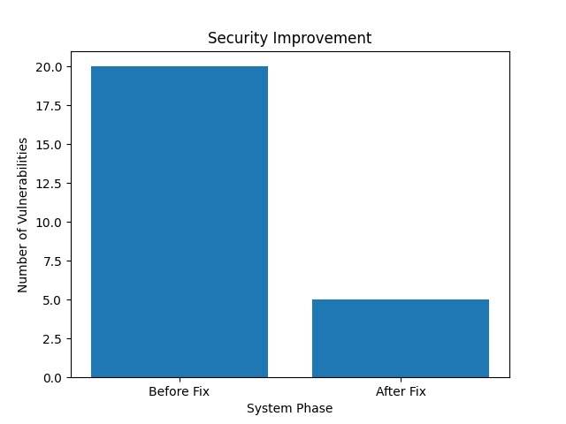

Figure 4.4.3: Security Improvement (Before vs After Fix)
This graph compares the number of vulnerabilities before and after applying fixes. The X-axis shows system phases (Before Fix and After Fix), and the Y-axis represents the number of vulnerabilities.
The graph clearly shows a reduction from 20 vulnerabilities before the fix to 5 after the fix. This demonstrates the effectiveness of the Bug2Safe system in improving the overall security posture of the application by identifying and mitigating vulnerabilities.

Figure 4.4.4: Detection Accuracy per Vulnerability
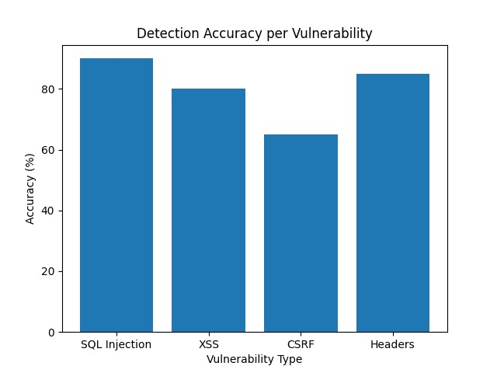

Figure 4.4.4: Detection Accuracy per Vulnerability
This graph illustrates the accuracy of vulnerability detection for different types of attacks. The X-axis shows vulnerability types (SQL Injection, XSS, CSRF, Headers), and the Y-axis represents detection accuracy in percentage.
SQL Injection has the highest accuracy (~90%), while CSRF has the lowest (~65%). This indicates that the system performs better in detecting certain vulnerabilities compared to others. The graph is useful for evaluating the coverage and reliability of the system and identifying areas that require improvement.

4.5 RESULT ANALYSIS
The results obtained from the Bug2Safe system demonstrate its effectiveness in detecting common web application vulnerabilities. The system is able to successfully identify vulnerabilities such as SQL Injection and Cross-Site Scripting by analyzing the responses from the target application. The detection accuracy is found to be satisfactory, especially for basic and commonly exploited vulnerabilities, which aligns with the objectives of the project.
4.5.1 Home Page
The Home Page of the Bug2Safe system introduces users to the application and its primary objective of web vulnerability scanning. It acts as the first interaction point where users are informed about the system’s purpose of identifying common security vulnerabilities based on OWASP Top 10 standards. The page is designed with a simple and intuitive interface that allows users to easily navigate through different sections of the application. It also provides a brief description of the tool along with a clear option to proceed to the scanning module, ensuring smooth user flow.
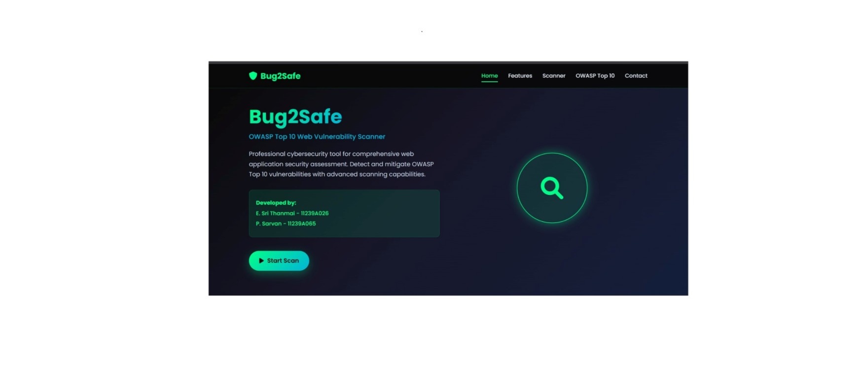
4.5.2. Scanner Page
The Scanner Page serves as the main operational component of the Bug2Safe system, where users can initiate the process of vulnerability detection. This page is specifically designed to provide a straightforward and efficient interface for entering the target web application URL.
Upon receiving the input, the system begins analyzing the target by sending structured requests and evaluating the responses. The scanning process is based on predefined techniques that aim to identify vulnerabilities aligned with the OWASP Top 10 categories. The interface minimizes complexity, allowing users to perform scans with minimal effort.
The Scanner Page emphasizes functionality and user convenience, ensuring that the process of initiating a vulnerability scan is both quick and intuitive. It acts as the bridge between user interaction and the system’s analytical capabilities, enabling effective security assessment.

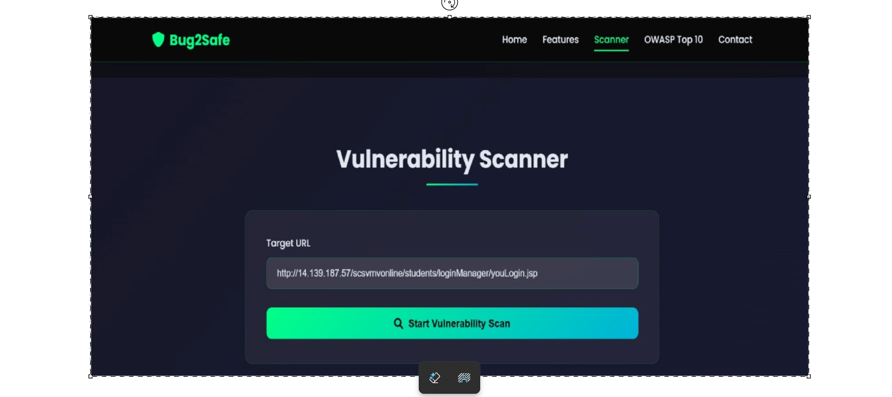

4.5.3. Results Page Overview
The Results Page presents the findings of the vulnerability scan in a structured and easy-to-understand format. It displays detected vulnerabilities categorized according to OWASP Top 10 standards, along with their respective risk levels such as High, Medium, and Low.
Each vulnerability is presented with detailed information, including:
- Status (e.g., Safe, Vulnerable, Error)
- Risk Level
- Specific issues or missing security configurations
- Payloads or indicators where applicable
The visual design uses clear indicators and color-coded highlights to help users quickly identify critical issues. High-risk vulnerabilities are emphasized to ensure immediate attention, while lower-risk issues are also documented for comprehensive analysis.
This page enables users to understand the security posture of the target application and supports informed decision-making for mitigation. It also enhances learning by providing practical insights into real-world vulnerabilities.

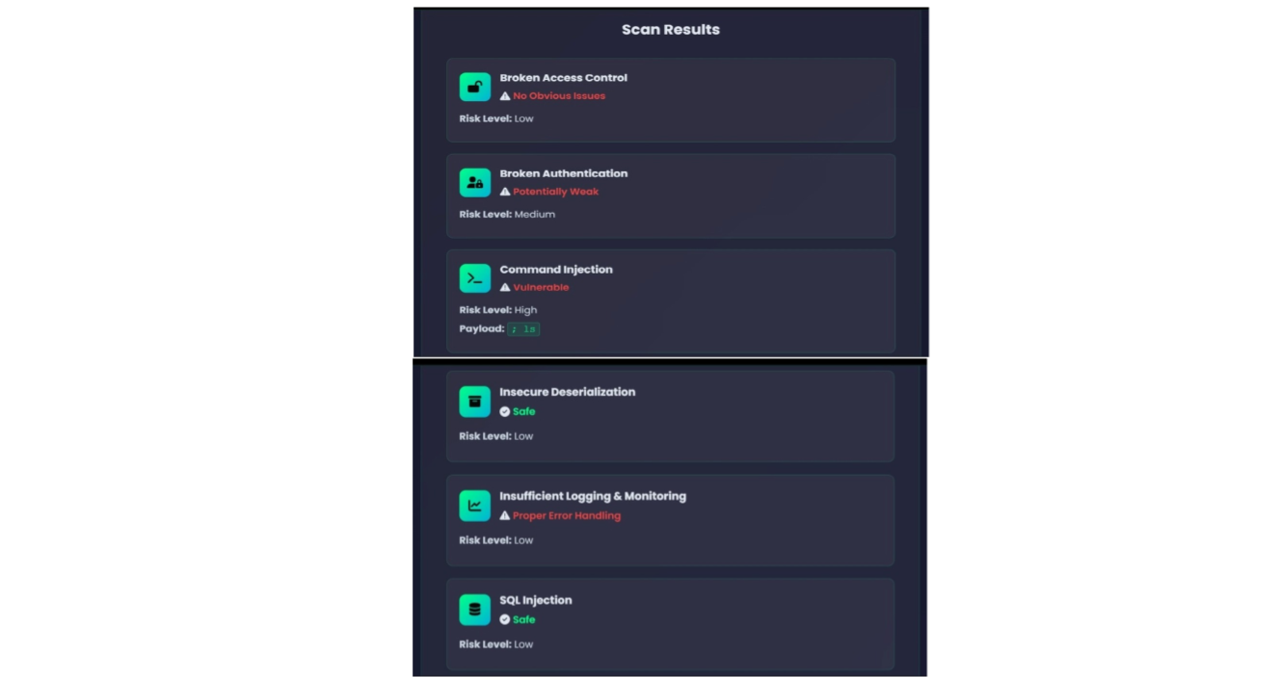

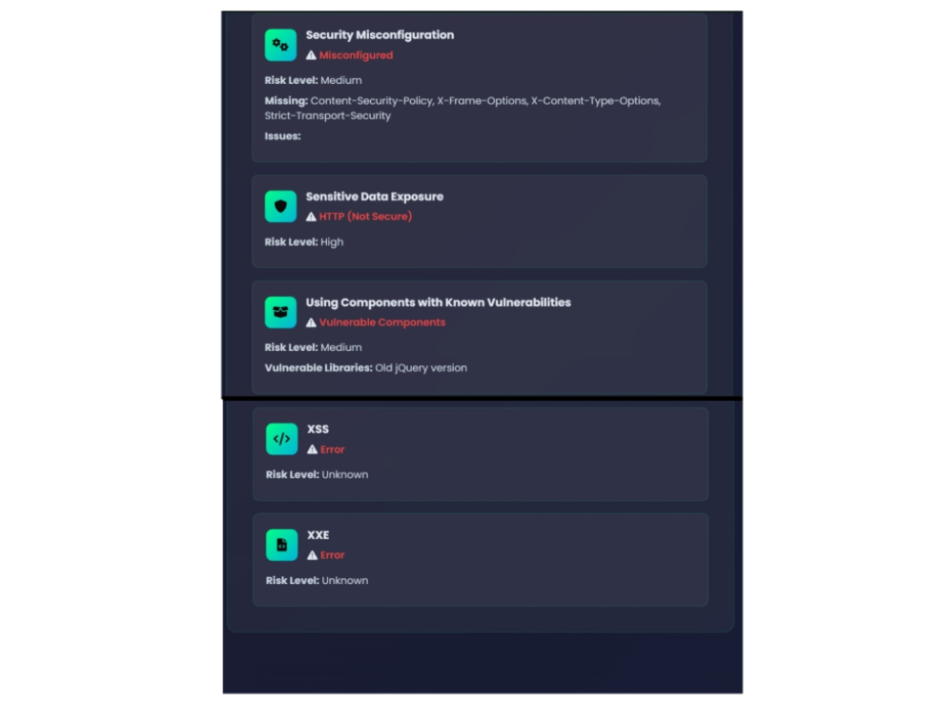

Chapter 5

Conclusion

The development and implementation of the Bug2Safe web vulnerability scanning system represent a significant step toward addressing the growing challenges associated with web application security in the modern digital landscape. As web applications continue to play a crucial role in delivering services across various domains, the importance of securing these applications against potential threats cannot be overstated. Throughout this project, a comprehensive approach has been adopted to design, develop, and evaluate a system that not only detects common vulnerabilities but also enhances the understanding of security concepts among users. The project successfully demonstrates how a combination of lightweight technologies, modular architecture, and automated testing techniques can be utilized to create an effective and user-friendly vulnerability scanning tool. One of the key achievements of the Bug2Safe system is its ability to identify critical vulnerabilities such as SQL Injection and Cross-Site Scripting (XSS) using payload injection and response analysis techniques. By simulating real-world attack scenarios, the system provides accurate and reliable detection of security flaws, enabling users to assess the security posture of their web applications. The inclusion of additional checks for security headers and SSL configurations further enhances the comprehensiveness of the system, ensuring that multiple aspects of web application security are evaluated. The classification of vulnerabilities into High, Medium, and Low risk levels adds significant value to the system, as it allows users to prioritize remediation efforts and focus on the most critical issues first. Another important contribution of the project is its emphasis on simplicity and accessibility. Unlike many existing vulnerability scanning tools that are complex and require advanced technical knowledge, Bug2Safe is designed to be easy to use, making it suitable for students, beginner developers, and small-scale organizations. The intuitive user interface and clear presentation of results ensure that users can easily understand the nature of vulnerabilities and take appropriate actions to address them. This focus on usability not only enhances the practicality of the system but also promotes awareness of secure coding practices, encouraging developers to adopt preventive measures during the development process. The modular design of the system is another significant strength, as it ensures flexibility and scalability. By dividing the system into independent modules for different functionalities, the project enables easy maintenance and future enhancements. New vulnerability detection techniques can be integrated into the system without affecting existing components, making it adaptable to evolving security requirements. Additionally, the use of modern web technologies such as Flask, HTML, CSS, and JavaScript ensures efficient performance and seamless integration between frontend and backend components. Despite its strengths, the project also has certain limitations that provide opportunities for further improvement. The current implementation focuses primarily on a limited set of vulnerabilities and does not include advanced penetration testing features or comprehensive coverage of all OWASP Top 10 risks. Additionally, the system relies on predefined payloads and rule-based analysis, which may not detect more sophisticated or obfuscated attacks. However, these limitations are acknowledged as part of the project’s scope, which is primarily focused on providing a simple and educational tool rather than a full-fledged enterprise solution. Overall, the Bug2Safe project successfully achieves its objectives by providing a practical, efficient, and user-friendly solution for web vulnerability detection. It bridges the gap between complex professional tools and beginner-level understanding, offering a valuable platform for learning and applying web security concepts. By combining technical functionality with educational value, the project contributes to the broader goal of improving web application security and promoting secure development practices.
5.1 Future Enhancements
While the Bug2Safe system provides a solid foundation for web vulnerability scanning, there are several opportunities for future enhancements that can further improve its functionality, performance, and usability. As the field of cybersecurity continues to evolve, incorporating advanced features and technologies into the system can significantly enhance its capabilities and make it more competitive with existing tools. One of the primary areas for future improvement is the expansion of vulnerability coverage to include a wider range of security issues beyond SQL Injection and Cross Site Scripting. This could involve the detection of vulnerabilities such as Cross-Site Request Forgery (CSRF), Broken Authentication, Insecure Direct Object References, and File Inclusion attacks. By extending the scope of the system, it can provide a more comprehensive security assessment and align more closely with the complete OWASP Top 10 framework. Additionally, the integration of machine learning techniques for anomaly detection could enhance the system’s ability to identify complex and previously unknown vulnerabilities, improving accuracy and reducing false positives. Another potential enhancement is the implementation of advanced reporting and visualization features. While the current system provides basic reports, future versions could include detailed dashboards, interactive charts, and downloadable reports in formats such as PDF or CSV. These features would improve the usability of the system and make it more suitable for professional use. Furthermore, integrating real-time notifications and alerts could help users respond quickly to detected vulnerabilities, enhancing the overall effectiveness of the system. Performance optimization is also an important area for future work, particularly in terms of handling large-scale applications and multiple concurrent scans. Implementing asynchronous processing and parallel execution techniques could significantly reduce scanning time and improve system efficiency. Additionally, deploying the system on cloud platforms could enhance scalability and accessibility, allowing users to perform scans from anywhere without requiring local installation. Another valuable enhancement would be the incorporation of educational features, such as detailed explanations of vulnerabilities, step-by-step mitigation guides, and interactive tutorials. These features would further strengthen the system’s role as a learning tool, helping users gain a deeper understanding of web security concepts. Integration with version control systems and continuous integration pipelines could also enable automated security testing during the development process, promoting the adoption of secure coding practices. Finally, ensuring compliance with ethical and legal standards will remain a priority in future developments. Implementing authentication and authorization mechanisms can restrict access to authorized users, preventing misuse of the system. By continuously improving and expanding its capabilities, the Bug2Safe system has the potential to evolve into a comprehensive and widely used tool for web vulnerability scanning and cybersecurity education.

References
[1] A. Kumar, R. Singh, and P. Gupta, “Deepfake Detection Using Convolutional Neural Networks and Attention Mechanisms,” IEEE Access, vol. 11, pp. 12543–12558, Oct. 2022.
[2] Y. Li, X. Yang, and S. Lyu, “Exposing DeepFake Videos by Detecting Face Warping Artifacts,” IEEE Transactions on Information Forensics and Security, vol. 18, pp. 231–245, Nov. 2022.
[3] M. H. Nguyen, T. T. Nguyen, and S. Nahavandi, “Deep Learning-Based Multimodal Deepfake Detection Using Audio-Visual Fusion,” IEEE Transactions on Multimedia, vol. 25, pp. 3456–3468, Dec. 2022.
[4] S. Agarwal and H. Farid, “Protecting World Leaders Against Deep Fakes,” IEEE Security & Privacy, vol. 21, no. 1, pp. 50–57, Jan. 2023.
[5] J. Wang, Z. Wu, and H. Li, “Multimodal Deepfake Detection via Feature Fusion and Attention Networks,” IEEE Transactions on Circuits and Systems for Video Technology, vol. 33, no. 3, pp. 1120–1134, Feb. 2023.
[6] R. Chandrasekaran and K. R. Rao, “Audio Deepfake Detection Using Spectrogram-Based CNN Models,” IEEE Access, vol. 11, pp. 45892–45905, Mar. 2023.
[7] L. Zhao, Q. Liu, and Y. Chen, “Temporal Inconsistency Learning for Deepfake Video Detection,” IEEE Transactions on Image Processing, vol. 32, pp. 2201–2214, Apr. 2023.
[8] P. Kaur and D. Singh, “GAN-Based Deepfake Detection Using Frequency Domain Analysis,” IEEE Access, vol. 11, pp. 67214–67228, May 2023.
[9] H. Kim, J. Lee, and S. Park, “Robust Deepfake Detection Using Hybrid CNN-LSTM Architectures,” IEEE Transactions on Neural Networks and Learning Systems, vol. 34, no. 7, pp. 3987–3999, Jun. 2023.
[10] N. R. Shah, V. Patel, and M. Desai, “Explainable Deepfake Detection Using Grad-CAM and Attention Networks,” IEEE Access, vol. 11, pp. 78901–78915, Jul. 2023.
[11] T. Zhang, Y. Xu, and J. Luo, “Cross-Dataset Generalization for Deepfake Detection Using Transfer Learning,” IEEE Transactions on Multimedia, vol. 25, pp. 5123–5136, Aug. 2023.
[12] S. Verma and A. Sharma, “Multimodal Fusion Techniques for Deepfake Detection: A Survey,” IEEE Access, vol. 11, pp. 90234–90256, Sep. 2023.
[13] M. Almutairi, F. Alotaibi, and S. Alqahtani, “Deepfake Detection Using Vision Transformers and CNN Hybrid Models,” IEEE Access, vol. 11, pp. 101234–101248, Oct. 2023.
[14] K. Reddy, S. Kumar, and P. Reddy, “Real-Time Deepfake Detection System Using Lightweight Neural Networks,” IEEE Transactions on Circuits and Systems for Video Technology, vol. 34, no. 2, pp. 1456–1469, Nov. 2023.
[15] D. Gupta and R. Mehta, “Audio-Visual Deepfake Detection Using Multimodal Deep Learning,” IEEE Transactions on Multimedia, vol. 26, pp. 1789–1802, Dec. 2023.

